Turtle Graphics with Python!

A Teknowledge Activity

# Basics

Go to [bit.ly/tkturtle](http://bit.ly/tkturtle) in your internet browser.

Below that, we have:

|  |  |
| --- | --- |
| 4  5  6 | turtle.Screen().bgcolor("black")  turtle.color("white")  turtle.shape("turtle") |

line #4 - sets the screen background color to black

line #5 - sets the turtle color to white

line #6 - sets the turtle to be shaped like a turtle

If you put different words inside the parenthesis and quotation marks, you can change what these lines of code will do!

**Challenge 1: Change the background color and turtle color to colors that you like!**

# Let’s Get Moving

We can tell the turtle to go forward or backwards a certain number of pixels like so:

|  |
| --- |
| turtle.forward(50)  turtle.backward(100) |

The number you put in the parenthesis is the number of pixels to move.

**Challenge 2: Try moving the turtle off the screen forwards, then off the screen the other way, backwards, then back to the original spot.**

We can also tell the turtle to turn by a certain number of degrees (360 will turn in a full circle).

|  |
| --- |
| turtle.left(45)  turtle.right(360) |

**Challenge 3: Draw a square and a “+” using the turtle.**

If you’re stuck: Try drawing the shape on a piece of paper without lifting it up. As you draw, describe your movements, in code!

# Now We’re Going Places: Coordinates

We can tell the turtle to go to a specific location like this:

|  |
| --- |
| turtle.goto(100, 50) |

The two numbers are (x, y) values in a coordinate plane like this.

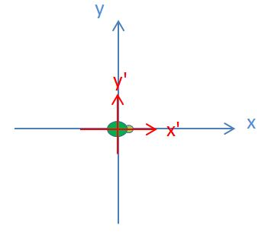

Positive numbers for x go **right**.

Positive numbers for y go **up**.

**(0, 0)** is in the middle of the screen.

**Challenge 4: Make the turtle draw a basic house (like the one shown below), using only turtle.goto commands, starting with this line of code:**

|  |
| --- |
| turtle.goto(50, 50) |

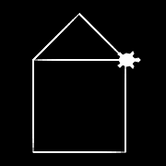

If you’re stuck: Pick which line you want to draw first, and go one line at a time. Experiment with different numbers and see if the turtle went where you expected.

# Pen and Stamp and Text Party

Sometimes you don’t want the turtle to draw a line when it moves.

You can “lift” and “lower” the “pen” with this code:

|  |
| --- |
| turtle.penup()  turtle.forward(20)  turtle.pendown()  turtle.forward(20) |

You can also “stamp” the turtle with this code:

|  |
| --- |
| turtle.stamp()  turtle.forward(100) |

And you can write text onto the screen with this code:

|  |
| --- |
| turtle.write("YEAH") |

**Challenge 5: With these new skills, try to create this image as close as you can with your turtle:**

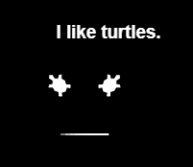

If you’re stuck: Remember to use “Turtle.penup()” and “Turtle.pendown()” when you want to move the turtle without drawing on the way there.